


Chapter1: Portfolio
Team: 10129
Stem October
DRAFT
Grade 10 Semester 1 2024-2025
Names: Samy Mohamed, Islam Essam, Mahmoud Khalid, Mohamed Gamal and Ahmed Hany

URBAN CONGESTION
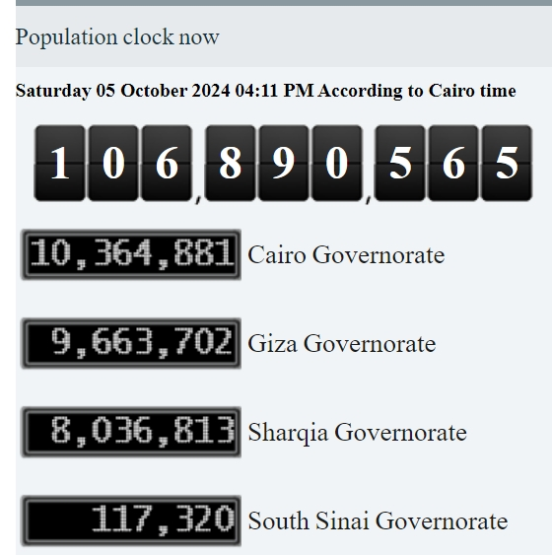
The urban congestion problem is dangerous because it consumes most of the country's resources. The population in Egypt is 106,890,565, according to the Central Agency for Public Mobilization and Statistics (CAPMAS) as shown in Figure 1.

Urban congestion is remarkably high in Egypt, especially in Cario because it contains 10,364,881 people (about half the population of New York) as shown in Fig 1. Cairo is populated with 10% of Egypt’s population while only 0.3% of Egypt’s total area. The average annual growth rate at 1.57%. The Greater Cairo Metropolitan Area (GCMA) contains more than 19 million people which is more than one-fifth of Egypt’s population.
Figure 1 population in Egypt
Urban congestion is a serious problem in the (GCMA) that causes traffic congestion that affects personal travel time, air quality, public health, and business operations.

CAUSES OF URBAN CONGESTION

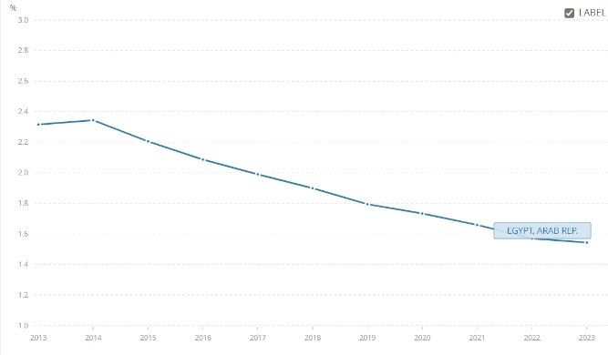
Increase in birth rate
Figure 2
The birth rate in Egypt is in continuous decrease as shown in Fig (2)
And in 2023 the birth rate is 1.57% as illustrated in Figure (2)

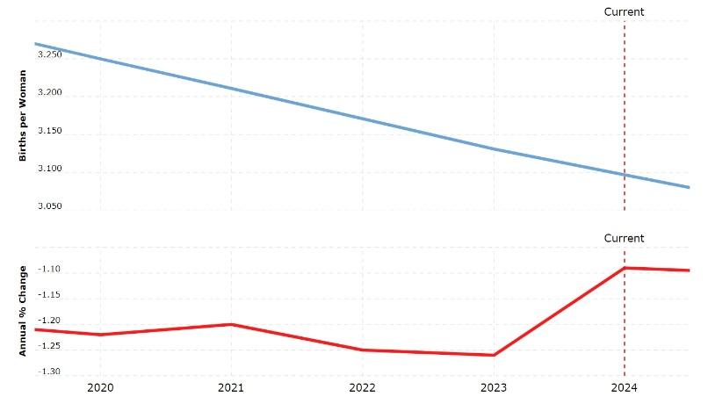
Egypt has one of the largest populations in the Middle East. High fertility in many parts of Egypt causes overpopulation leading to urban congestion. The current fertility rate for Egypt in 2024 is 3.097 births per woman, a 1.09% decline from 2023 as shown in figure (3).
Figure 3 fertility rate

Figure 3

- BAD PEOPLE DISTRIBUION
Figure 4
Egypt’s area is 1002000 KM^2, however, only 105199 KM^2 is inhabited by people. Most of the population is around the Nile banks leaving large arid areas in Egypt, and urban congestion in all populated cities. While the population grows. The population in Egypt centered in Cairo and Giza. There are 18.73% of Egyptians only in these two cities. 10,365,881 Egyptian and 9,663,702 in Giza of 106,890,565 according to the Central Agency for Public Mobilization and Statistics, as shown in figure 4.

3. URBANIZATION:
Urbanization is the movement of people from rural areas to cities searching for better opportunities. As shown in figure (5) the growth of Egypt's rural and urban population, in 2023, the share of the urban population in Egypt remained nearly unchanged at around 43.1 percent. Today, the urban population is projected to outnumber people living in rural areas for the first time in 2041. By that time, 69 million people will reside in urban areas.
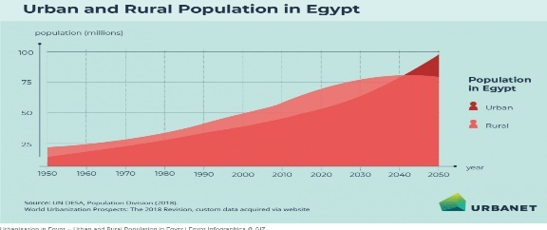

figure 5 urban and rural population in Egypt

IMPACTS OF URBAN CONGESTION

1. PUBLIC HEALTH
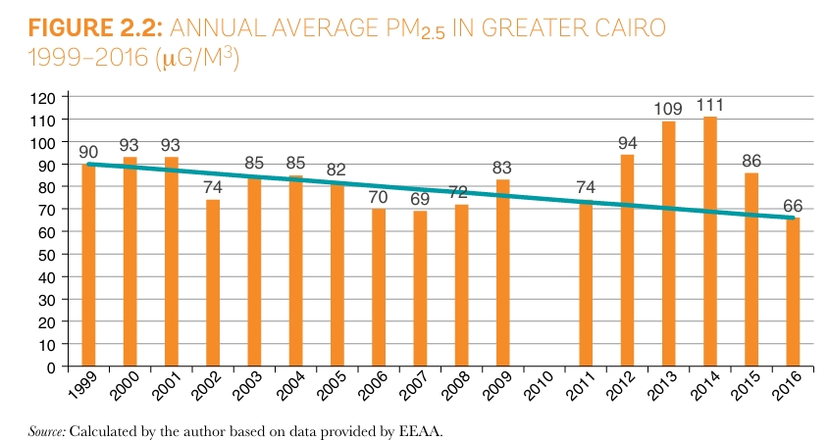
Urban congestion and lack of clean sanitation services increase the risk of contagion, 8.4 million people are deprived of access to improved sanitation, mostly in rural areas. While good urbanization can bring health and benefits for the economy, bad urbanization can have negative health impacts and environmental impacts, 48.1% of all trips are taken by private automobiles which increases air pollution. In air pollution, urban congestion leads to increased emissions from exhaust vehicles making the air quality too poor causing respiration problems and other health problems. In 2019, 16% of deaths in Egypt were due to air pollution and in 2017, 19,200 people died prematurely due to PM2.5 air pollution. As shown in fig. (6) that illustrates the PM2.5 in Egypt. The primary source of PM2.5 in the greater Cairo area is load transport 33% and private cars and taxis account for 80%.
Figure 6

Children under 5 with ARI WAS 10.7 from total Egypt in 2021 as exposed in Figure 7
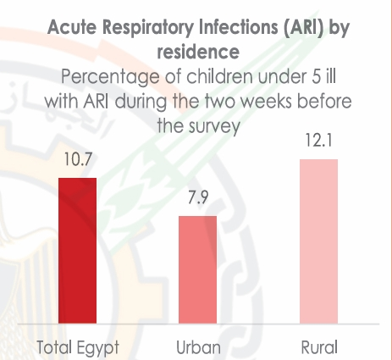
Figure 7

2. SOCIAL IMPACT:
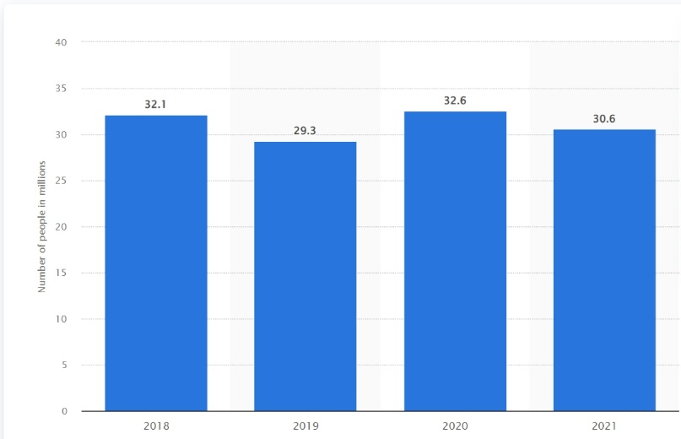
Egypt ranks NO. 35 overall in the U.S. News best countries ranking. Urban congestion reduces the quality of life as there is no time for visiting family, leisure, and rest. This can increase stress and reduce overall life satisfaction. From a social Isolation view, longer travel times can lower social interactions and community engagement. People may be less likely to visit friends and family or take part in community activities if it takes too long to get there. At the Social Inequality level, lower-income individuals who rely on public transportation are often more affected by congestion. Delays and unreliability in public transport can lead to social disparities in society. Urban congestion in Egypt reduces job opportunities as the population is 106,890,565 in Egypt so that increases the poverty in Egypt as illustrated in fig. (8).
Figure 8 NO. of people living under the poverty line in Egypt from 2018 to 2021

Figure 4

3. ECONOMIC IMPACT:
Urban congestion increases fuel consumption as in 2024 Egypt spends 331 billion Egyptian pounds (6.85 billion) on fuel, while in 2017, fuel consumption in Egypt included petroleum and gas consumption of 27,120 tons per year. The economic costs of traffic congestion in Cairo could be as high as 4 percent of GDP yearly. The economic costs of congestion are beyond travel delays, and they include wasted fuel, health impacts due to poor air quality and accidents, and impacts on economic productivity. When combined, the yearly economic cost of traffic congestion could reach up to 4% of Egypt’s GDP. This means a financial cost to Egypt of up to EGP 50 billion a year (USD 8 billion/year).

Improving the use of arid areas
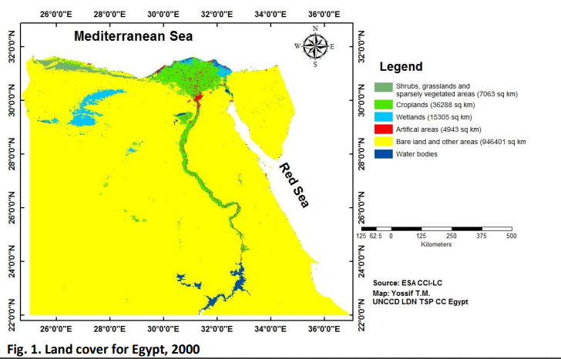
Egypt is a large country that covers an area of 1,002 million square kilometers, The country has a strategic geographic location that connects Asia and Africa and connects the Mediterranean and red seas through the Suez Canal. However, despite the large size of Egypt, it suffers from many problems like urban congestion and insufficient agricultural production. This is because 96% of Egypt’s land is barren, as shown in Figure 9.
Egypt’s desert lands can be split into 3 main areas, The western desert, The eastern desert, and The Sinai Peninsula. Despite low or non-existent agricultural production, these areas produce crude oil and/or natural gas.
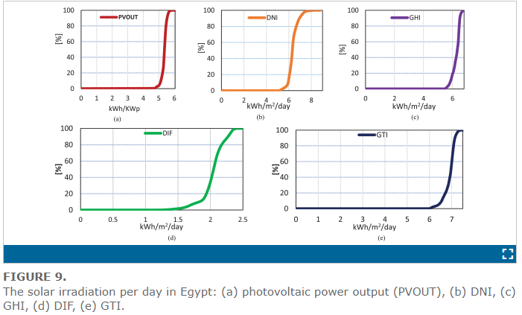
The western desert has 56% of Egypt’s crude oil production and natural gas equals 18% of Egypt’s natural gas production. The eastern desert produces 12% of Egypt’s crude oil. The Sinai Peninsula produces 9% of Egypt’s crude oil. However, all these areas have a very low, barely existent agricultural production, The oases in the region do not make a tangible difference in the overall agricultural production. Therefore, the development of these arid areas for agricultural production is needed. Furthermore, Egypt's geographic location makes it a perfect candidate for solar energy production as the highest direct normal irradiation (DNI) it receives is 3069 kWh/m²/y in south Sinai and the lowest is 1890 kWh/m²/y in Alexandria. The global solar atlas of Egypt is shown in Figure 10.
Figure 9
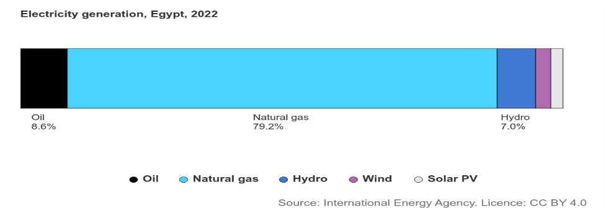
Despite the perfect locations for generating solar power like the Sinai Peninsula, Western Desert and Eastern Desert, solar energy consumption only made up 2.4% of Egypt’s total energy consumption in 2022, which is shown in Figure 11. Which is due to Egypt not utilizing its vast arid areas properly.
Figure 11
figure 10
Source 1:https://ieeexplore.ieee.org/document/9668970?denied=
Causes
1. Geographic Location
Due to Egypt’s location in north Africa, 96% of the country’s surface area is covered by the western and eastern deserts, both of which are part of the Sahara desert, One of the hottest and driest of the world’s deserts with temperatures reaching up to 57.7 Celsius with extremely rare rain falls as inland Sahara only receives 1.5 cm of rainfall per year, greatly limiting the habitability of the western and eastern deserts in non-coastal areas and making construction of large mines in most of the two deserts extremely difficult if not impossible, and not economically efficient.
2. Land Composition
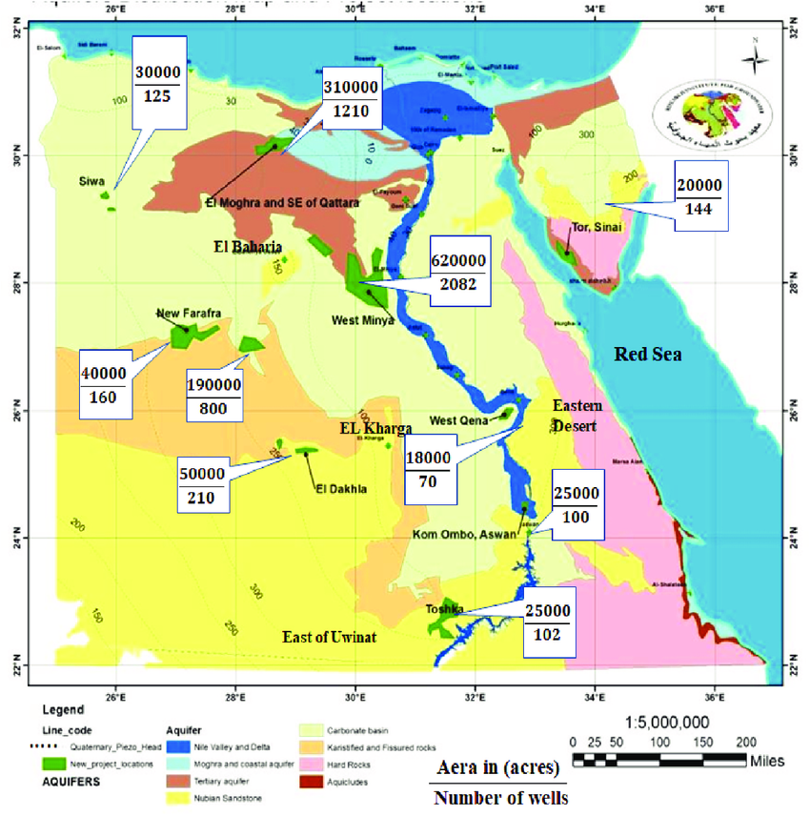
Due to the land composition in the Western and Eastern deserts agricultural production outside of the few scattered oases in them is complicated as the Western desert for example is mostly rocky which is not suitable for agricultural production with 10% of its area being a dune called the Great Sand Sea which is also not suitable for agricultural production as it is a dune. The land and soil composition of the western desert is shown in Figure 12. The most suitable locations for agricultural production in the western desert are the few major oases in the desert, however, the water in the groundwater supplies of these oases is too saline for irrigation for example the water in Siwa Oasis is measured at 2198–14,561 µS/cm conductivity on 96% of the studied water which is above the permitted limit for irrigation that is 700 µS/cm. Such high conductivity resulted from the high concentration of TDS (total dissolved solids) and mineralization of organic materials. The TDS values ranged from 1367 to 8645mg/l. Such high salinity values are likely to be the result of the dissolution of limestone, dolomite, and evaporite deposits in the area. Consequently, The Western desert and the eastern desert soil are not suitable for agricultural production in their current state.
figure 12
5 figure 4

3. Lack of Water Resources
The arid areas of Egypt lack water resources as the only water sources in Egypt (apart from oases and groundwater) are the Nile River and smaller bodies of water near it like Lake Nasser as 90% of Egypt’s water supply comes from the River Nile alone with an annual share of 55 m3 billion, according to the United Nations Department of Economic and Social Affairs. Arid areas away from the Nile River must instead depend on groundwater and rain. Since arid areas like the western desert only receive 1.5 cm of rainfall per year (except for the north Mediterranean coast) they must depend on groundwater instead. Groundwater in arid areas, for example, the western desert in oases like Siwa Oasis has water conductivity measured at 2198–14,561 µS/cm which is higher than the permitted 700 µS/cm for irrigation, Limiting the uses of groundwater in the region even more and making it more difficult to utilize the arid areas.

Impacts
1. Population Increase in the Nile
As a direct result of mismanaging the arid areas (96% of the total area) of Egypt and not utilizing them to their fullest potential, it has caused problems for Egypt, one of which is urban congestion along the Nile River banks and Delta (4% of the total area) as more than 90% of the population (more than 96 million people) live along the narrow Nile banks due to it being the only water source besides lakes like lake Nasser and groundwater scattered across the country and being the agricultural hub of Egypt.
2. Agricultural Production Deficit
96% of Egypt’s surface area is a barren desert with harsh conditions, not suitable for agricultural production. Only the remaining 4% which equals 40,058 square kilometers of land are suitable for agricultural production which is insufficient for the Egyptian population of 106 million people. This forces Egypt to rely on imports to satisfy its deficit in agricultural production, As Egypt imports 40% of its food requirements which has an annual cost of 2.5 billion USD according to FAO. This is due to Egypt not fully utilizing its arid areas, especially for agricultural production.

3. Insufficient Solar Power Utilization
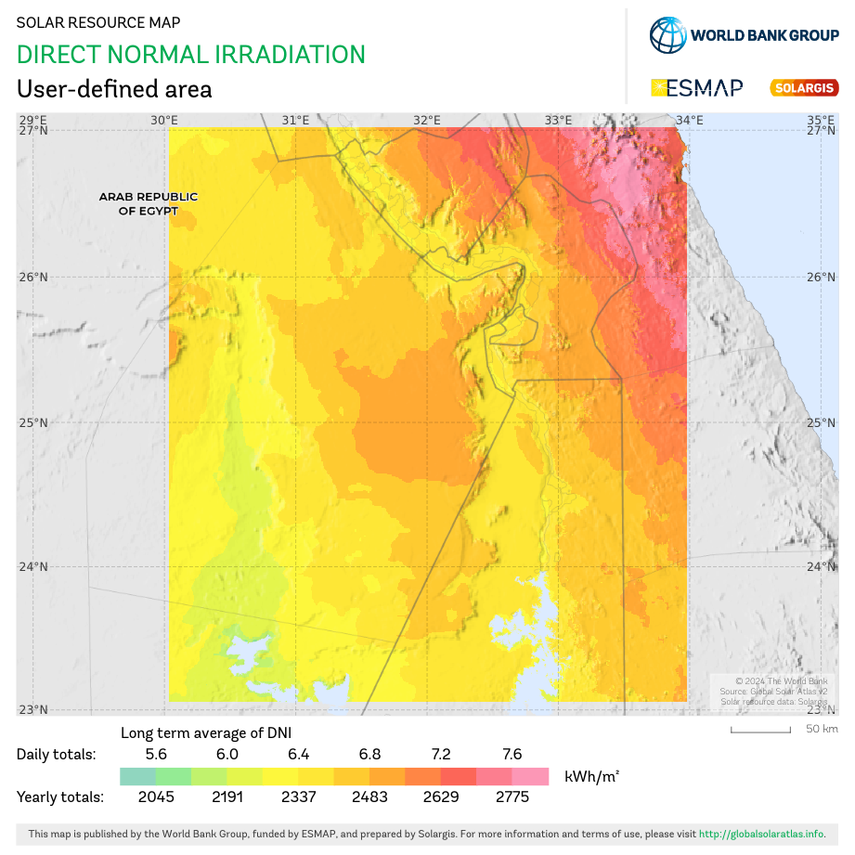
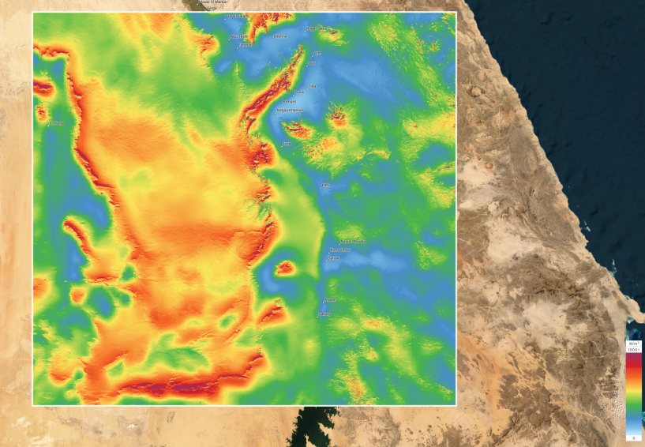
Only about 4% of Egypt’s energy consumption which was is solar energy and wind energy, which is a low percentage compared to the possible solar and wind energy output of Egypt due to the mean power density it receives. For example, the mean wind power density at a height 100 meters south of the western desert in the new valley is 716 W/m² as shown in Figure 13, and the direct normal irradiation it receives, which is equal to 5.95-7.12 kWh/m2 as shown in figure 14. This low percentage comes back to the expensive price of the wind turbines, solar panels, and batteries needed to generate enough solar energy to satisfy Egypt’s electricity consumption, the time needed to construct the wind turbines and solar panels, and the maintenance cost of the solar panels and wind turbines due to the climate of the arid areas in Egypt.
figure 13 mean wind power density at 100m in the new valley area
Figure 14
2 source: global wind atlas https://globalwindatlas.info/en/

Population growth
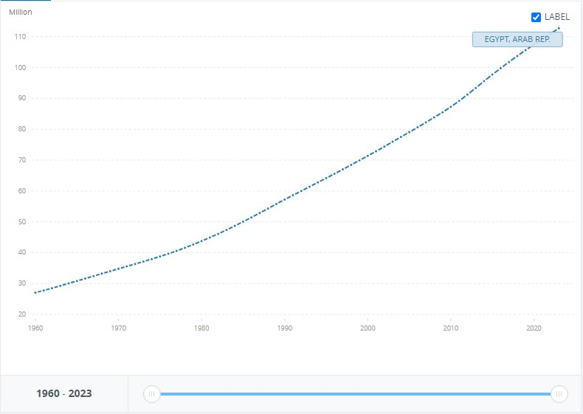
One of, if not, Egypt’s greatest grand challenges is population growth. By the years, population in Egypt severely increases with a high ratio, causing huge problems.
As shown in figure 15, population went from 27M to 112M in 63years with 414% increase in population and 2% growth a year. Birth numbers exceeding deaths’ makes Egypt more and more crowded than ever in each minute passing. So over only 63 years there are 85M more people living on the same space, resources, food and national income while a lot of them don’t work because of high unemployment.

Figure 15, population in Egypt
Reduction of resources and hard life for the individuals living in Egypt are the consequences of population growth. Making it a difficult challenge for Egypt to face.

While some cities in Egypt are the most populated, for instance, Cairo itself is populated with 10% of Egypt’s population, 10,364,881 in numbers. When it’s only 0.3% of Egypt’s total area, equal to 3,085KM^2. Showing how bad the population distribution is in Egypt.

Causes

- Early marriage

In the past years, it was a tradition that girls should marry early. Marring in the age of 13 and 14. In the countryside and southern Egypt, it’s considered a shame for reaching 20 years old without marriage. Which makes large amount of births in a short period of time. Exceeding deaths and growing population.

16% marry under the age of 18. And 2% marry under the age of 15. Meaning 1 in 6 women is married before their 18th birth day. In total 8.1M women are wed under 18 to date according to UNICEF. 15.8% of child prevalence in Egypt 2021.

- Bad population distribution

Egypt’s area is 1002000 KM^2, however only 105199 KM^2 is inhabited by people. Most of the population is around the Nile banks leaving large arid areas in Egypt, and urban congestion in all populated cities. While population grows. Having the population in Egypt centered in Cairo and Giza. Having 18.73% of Egyptians only in these two cities. 10,365,881 Egyptian and 9,663,702 in Giza of 106,890,565 according to the central agency for public mobilization and statistics, as shown in figure 1.

- Poverty

27% of Egyptians were below the poverty line in 2023. Poor people marry early and give birth in large amounts, hoping their children will take care of them although, increasing population growth and the poor.

The current fertility rate for Egypt is 3.097 births per woman. Approximately 10M children live in poverty in Egypt, nearly 3 in 10 children and 28.8% of children live in extreme poverty according to UNICEF.

Impacts

- Pollution

Population growth increases pollution severely. Egypt is ranked the 9th in air pollution. And Egypt holds the 12th position in the global pollution index, with a score of 82.7 making it one of the most polluted countries in the world.
emissions from vehicles, industrial processes and agricultural activities are the reasons for high pollution levels.

- Economic pressure

Egypt’s spending in 2023/2024 reached 3 trillion EGP. Marking a 34% increase from the previous year. And the more of population growth the more money Egypt needs to provide essential needs for its civilians. While Egypt’s revenue for the year 2023/2024 is only 2.14 trillion EGP, putting Egypt under high economic pressure

Reduce and adapt climate change
Our climate is the earth’s normal weather over a long time. Climate change refers to long-terms shifts in temperature and weather patterns. it usually takes Hundreds or Thousands of years for the climate to change, but recently our climate has been changing much faster. From the years of 2000-2020 , average temperature in Egypt increased by 0.38 degrees Celsius per decade, a temperature increase that is higher than the world average. Climate change affects the environment in many different ways, including rising temperatures, sea level rise, drought, flooding, and more. These events affect things that we depend upon and value, like water, energy, transportation, wildlife, agriculture, ecosystems, and human health.

According to the United Nations Office for Disaster Risk Reduction, during the 1998–2017 period, 5.3% of all global disasters originated from high temperatures, whereas droughts caused 4.8%, severe storms 28.2%, and hurricanes 43.4%.1 In other words, 82% of natural disasters during this period were climate related. The 2014 report by the Intergovernmental Panel on Climate Change (IPCC) clearly states that "Changes in many extreme weather and climate events have been observed since about 1950. Some of these changes have been linked to human influences. cv

Causes

1. Fossil fuels

in 2020, Egypt was Africa’s largest non-OPEC oil producer and the second largest natural gas producer in the continent after Algeria. Egypt mainly relies on fossil fuels to meet its energy demand, with more than 90% of electricity generation coming from oil and natural gas, as shown in figure 16.
fig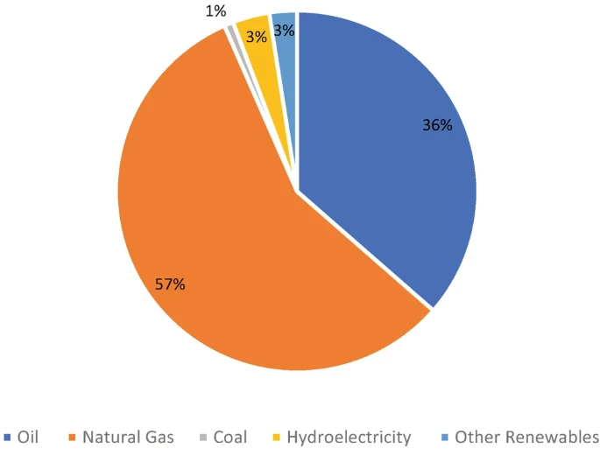
figure 16

In fact, Egypt is the largest consumer of fossil energy in Africa, with 22% of the continent’s petroleum and other liquids consumption and 37% of dry natural gas consumption in 2016.

When these fuels are burned, they emit carbon dioxide, a primary greenhouse gas, which is also a major cause of pollution and contributes to global warming. When we burn coal and oil, we emit Sulphur dioxide, which can cause respiratory difficulties and acid rain.

According to UNITED NATIONS, Fossil fuels – coal, oil and gas – are by far the largest contributor to global climate change, accounting for over 75 per cent of global greenhouse gas emissions and nearly 90 per cent of all carbon dioxide emissions.

As greenhouse gas emissions blanket the Earth, they trap the sun’s heat. This leads to global warming and climate change.

2. Cutting down trees
As trees grow, they help stop climate change by removing carbon dioxide from the air, storing carbon in the trees and soil, and releasing oxygen into the atmosphere. Trees provide many benefits to us, every day. They offer cooling shade, block cold winter winds, attract birds and wildlife, purify our air, prevent soil erosion, clean our water, and add grace and beauty to our homes and communities

Cutting down trees increase climate change. Egypt needs approximately 58 million square meters of parks and green spaces to keep its air clean and decrease climate change, yet currently only about 5.4 million square meters are available. Egypt lost 75% of its tree cover between 2010 and 2023 as shown in figure 17. Trees help stop climate change by removing cabon dioxide from the air, storing carbon in the trees and soil, and releasing oxygen into the atmosphere

figure 17

Impacts
1. rising temperature
The climate crisis has increased the average global temperature and is leading to more frequent high-temperature extremes, such as heatwaves. Higher temperatures can cause increased mortality, reduced productivity and damage to infrastructure. The most vulnerable members of the population, such as the elderly and infants, will be most severely affected.

Higher temperatures increase the evaporation of water, which – together with the lack of precipitation – increases the risks of severe droughts.

In fact, between 1850 and 2020, the average annual temperature in Egypt increased by around 1.6 degrees Celsius and Between 1901 and 2013 temperatures in Egypt increased by an average of 0.1°C per decade. most of the warming happening in just the past couple decades.
The rate accelerated between 2000 and 2020 with a temperature increase averaging 0.38°C per decade, which was higher than the world average (0.31°C per decade)

This graph shows how temperatures have changed since 1901, with the blue bars below the line showing cooler temperatures and the red bars above the line showing warmer temperatures. You can see in figure 18 how much the overall temperature has increased in just over 100 years.
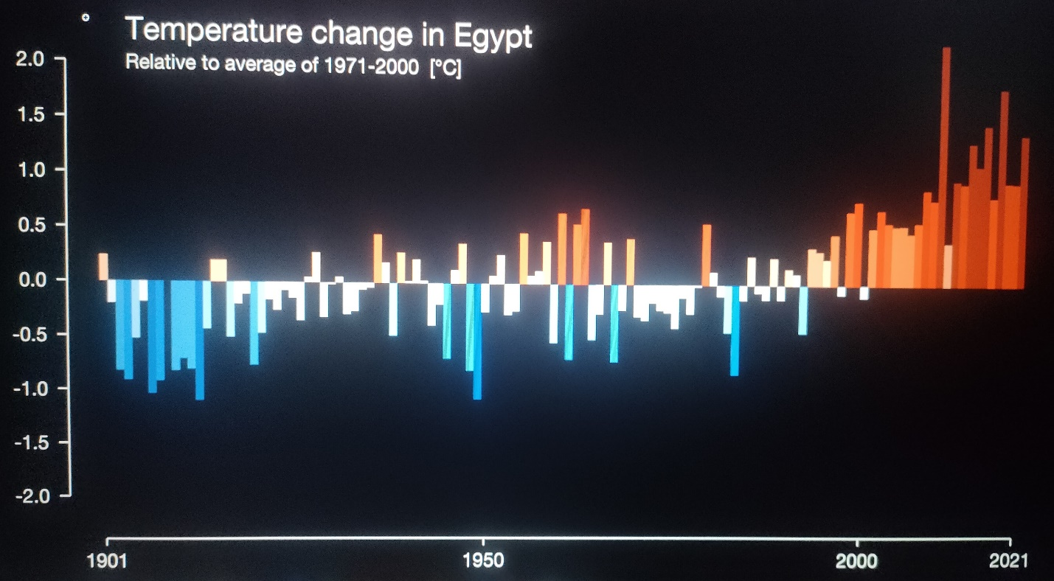Figure 18

2. Disruption of water resources
Climate change is already affecting water access for people around the world, causing more severe droughts and floods. Increasing global temperatures are one of the main contributors to this problem. Climate change impacts the water cycle by influencing when, where, and how much precipitation falls. It also leads to more severe weather events over time. Increasing global temperatures cause water to evaporate in larger amounts, which will lead to higher levels of atmospheric water vapor and more frequent, heavy, and intense rains in the coming years.
Almost two-thirds of the world's population experiences severe water shortages for at least one month of the year. Data from the World Health Organization indicate that about 85% of the world's population lives in the arid part of the planet, and that in many parts of the world the availability of water resources is decreasing. About 780 million people in the world do not have access to water, and about 2.5 billion people do not have access to adequate sanitation. Also, about 6 to 8 million people a year suffer the consequences of diseases caused by contaminated water.

Egypt is almost entirely dependent on the water of the Nile River, which supplies an annual water volume of approximately 55.5 km3, accounting for 93% of the country's conventional water resources. The annual total water demand is 81.3 km3, with approximately 86% for agriculture, 2.5% for industry, and 11.5% for the domestic sector. There is a gap between water demand and water availability, which is compensated for by the reuse of drainage water, wastewater, and shallow groundwater. The uncertainty of climate change impacts is another challenge to the water resources system in Egypt

In Egypt and In 2014, around 91 percent of the Egyptian population received water directly into their residence. However, while access to water is almost universal and reliable in urban areas, a significant number of households are still not connected with the water system in rural areas and in urban slums. 7.3 million people are deprived of access to safe water, among which 5.8 million live in rural areas and 1.5 million in urban areas. In rural areas, around 12 percent of the population live in dwellings not connected to the water system while, in urban areas, it’s 4 percent which do not have water connection. They are usually located in urban slums and poor settlements. In urban slum areas, only around 77 percent of households have piped water coming into their homes and in many cases the connection is illegal.

8.4 million people are deprived of access to improved sanitation, mostly in rural areas. Overall, 10 percent of the Egyptian population did not benefit from access to improved sanitation, with marked geographical and socio-economic disparities in 2014. In rural areas, on average, the share of population without access to adequate sanitation was around 15 percent in 2014, compared with around 1 percent among urban dwellers.

Problem to be solved
Urban congestion
Urban congestion is a frustrating problem. Facing every Egyptian, and being a great grand challenge for Egypt. With 2% growth rate of population a year, Egypt becomes more congested.
For instance, Cairo and Giza having a sum of 18.73% of Egypt’s entire population. 20,028,583 of 106,890,565 in numbers. Cairo itself being the most congested city in Egypt with 10,364,881 Egyptian equal to 9.7 %.
While the area of Cairo is 3,085 KM^2, being only 0.3% of Egypt’s area. Having 9.7% of Egyptians living in only 0.3% of Egypt, Explains why Cairo is positioned 57th in global traffic congestion behind cities like New York, London, and Paris. Showing the bad distribution of population, being the main cause of Urban congestion.
Teraat Al Ismailiyah road is a main road in Egypt. Being the main road connecting Cairo with El Ismailiyah governorate and El Swiss canal. It being so important is a reason for its congestion, as it’s a 218 km long and with a width of only 18m. it’s over congestion, makes it hard for cars to travel this long distance, meaning it’s the perfect road to search for a solution for.
Urban congestion being a factor of most of Egypt’s problem, for example, pollution, traffic accidents and fuel consumption, affecting Egypt’s economy. So by searching and analyzing the challenge of urban congestion, soon a solution will be found.

Positive consequences

- Less pollution

Car exhausts are major pollutants for air. Containing three major air pollutants that are harmful to the environment which are : carbon monoxide, nitrogen dioxide and carbon dioxide according to SOUTHWESTOHIOAIR.org.
Car pollution is 33% of Cairo’s air pollution concentration according to CLEANAIRFUND.org. Which is a huge deal considering Egypt’s 12th position in global pollution index and 9th in air pollution.
Urban congestion is a fatal cause of car pollution. And by solving it pollution will severely decrease of at least 10% by avoiding the combination of car exhaust’s pollutants. Having cleaner air, less polluted environment, cleaner and healthier food and cleaner water to drink from (as main roads are common around the Nile).

- Reduction of traffic jam

Due to urban congestion Egypt suffers from traffic jam in all its main roads. As a resultant of the close working hours in Egypt, being around 8AM to 4PM varying in different companies. The main roads always expect traffic jam around 7AM and 4PM. Causing a lot of traffic accidents,
according to a report of the central agency for public mobilization and statistics (CAMPAS), road accidents in Egypt has reached 71.016 just in 2023 while it reached 55.991 in 2022 with 27% increase only in one year. And the injury rate was 67.5 per 100,000 people in 2023 while being 54 per 100,000 with an increase of 25%.
Solving the urban congestion problem would reduce traffic jam and save large amounts of lives as traffic accidents’ deaths are 1.89% of total deaths ranking Egypt at 116th in traffic accidents’ death rate. And faster transportation inside Egypt will be reached.

- Economic and health benefits

Reducing urban congestion would reduce Egypt’s spending severely. as urban congestion causes the need for more resources to provide the services for Egyptians.

According to the global hunger index in 2023 Egypt sustains a moderate level of food insecurity, ranking 57th out of 125 countries. Egypt has a large water supply by having the Nile river but the congestion in cairo and Giza leads to over use of the water around it affect the quality of the water. according to capmas, 98.7% of Egypt’s water supply is through the Nile while only 66.7% of the population benefits from sanitation services leaving 33.3% drinking unsafe water. Making solving urban congestion benefit able.

Negative consequences

- High noise levels

The congestion in cities results high noise levels. The noise levels in Cairo are at 90dB, which can be compared to spending all day in a factory. While sounds over 85dB are considered a damage to your hearing. And it’s only safe to listen to sounds lower than 70dB.
Repeated exposures to loud noise can lead to permanent tinnitus and /or hearing loss, physical and psychological stress, reduce productivity, interfere with communication and concentration.

- Public health risks

Urban congestion is one of the main reasons of infection diseases and health pandemics. Peoples’ breaths in congested cities consuming oxygen and producing carbon dioxide polluting the air, risking the health of Egyptians. Congested vehicles’ exhausts gives the risks of lung diseases. The pandemics of infection diseases have higher risks as they are transported through air and breaths.

Research
Topics related to the problems

- Population in Egypt

One of the main topics to research on the urban congestion problem in Egypt is Egypt’s population. Being the main factor of urban congestion in any place. Since urban congestion is the congestion of the population in a certain area it’s essential to know about the population in the rural areas.
When researched on Egypt’s population it’s found out that the total population in Egypt is 106,890,565 growing by 1.57% since 1960 till 2024.the most populated cities in Egypt are Cairo, Giza and Sharqeia governorates which are 10,364,881 in Cairo, 9,663,702 in Giza and 8,036,813 in Sharqeia. Cairo being Egypt’s most congested city ranking 6th in most populated cities in the world falling after new York and London.

- Over pollution in Egypt

One of the main problems worldwide being the main cause for climate change and it’s mainly caused in Egypt by urban congestion which is why researching on it is important for identifying urban congestion.

When researched on pollution in Egypt it’s found that Egypt is ranked the 9th in air pollution. And Egypt holds the 12th position in the global pollution index, with a score of 82.7 making it one of the most polluted countries in the world. Cairo itself scores 95.8 out of 100 10 times above the safe limits being globally one of the most polluted cities in the world.

- Unemployment rate

One of the miserable consequences of urban congestion is unemployment. Due to the huge numbers of people there aren’t enough jobs to be provided for each person, being an important topic to search about.
Egypt’s unemployment rate is 6.40% of population, a 1.04% decrease from 2021 at 7.44%. the highest unemployment rate Egypt has reached was 13.40% in march 2014.

Topics related to solution

- Highway network

Highway network is one of the main factors of sustaining urban congestion for instance, Multilevel highways are multiple highways elevated over each other.
The road network in Egypt 65.050km long, 48,000km are paved. And the network of highways covers the country extending around 18,000km, Egypt is ranked 18th in global ranking of road quality advancing 100 countries.

- Flyovers and Overpasses

Flyovers and Overpasses are elevated roads built over critical congested road to reduce the congestion of traffic used on major and critical roads and highways
There are 4,159 flyovers and overpasses constructed over major roads in Egypt, as reducing traffic and urban congestion and improving connectivity between major roads

- Supports

A support is a part that is used on flyovers or bridges to support the deck and distribute the weights.
There are many types of supports, for instance, fixed support, roller support, pinned support and simple support, however, the most common used in Egypt is the hinged support for opening bridges and the ixed support for fixed decks used in 100% of the bridges of these criterias

Other Solutions Already Tried
Hawthorne Bridge

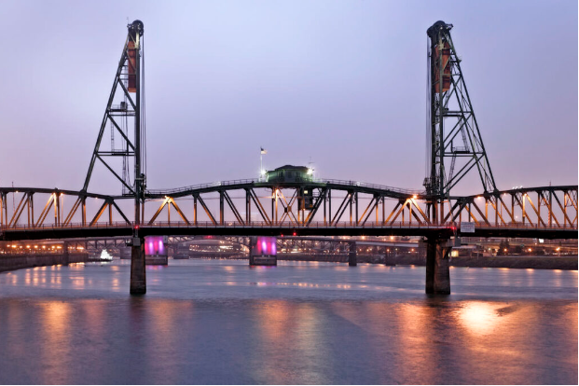
Hawthorne Bridge in Portland, USA is a 1082-meter-long, 22-meter-wide, 4-lane vertical lift bridge shown in Figure 1, it connects Hawthorne Boulevard and Madison Street by crossing The Willamette River. Originally constructed in 1910, It is the oldest operating vertical lift bridge in the United States of America, it is one of Portland’s busiest bridges, it can hold traffic of 30,000 motor vehicles/day, Including 800 TriMet buses, 8000 bicycles, and an untold number of pedestrians daily. It was designed by Waddell and Harrington, Consulting Engineers from Kansas City and MO. It opened to traffic on December 19, 1910, it was named after Dr. James C. Hawthorne, a physician and politician who co-founded the Oregon Asylum for the Insane in the 1850s. The bridge is of large importance due to connecting Hawthorne Boulevard and Madison streets which, in addition to their transportation importance, are home to many local businesses, which makes connecting them useful and important. In addition to the latter, according to Multnomah County, the bridge is used heavily by pedestrians and cyclists on a regular basis which adds to its importance. According to Transportation History in 2012, Hawthorne Bridge was added to the National Register of Historic Places in the USA which further proved its importance to Portland and the United States as a whole.
7Figure 1

Mechanism

Hawthorne Bridge is a vertical lift bridge that uses a system of counterweights and cables to move the lift span straight up and down. A vertical lift bridge is a bridge where the entire deck is lifted vertically by pulling on the four corners using two or four towers at either end of the open span while remaining horizontal. While the maximum height it can be raised is determined by the height of the towers, this system allows the bridge to be raised to the minimum height for a ship to pass beneath it, therefore minimizing the opening time and delays to traffic on the bridge. The operation of the bridge is by cables fixed to the open span. These cables pass over the top of the towers and are fixed to counterweight. The mechanism makes sure that the bridge travels upwards and the counterweights downwards. This ensures that everything is balanced during the vertical movement. The presence of the counterweights minimizes the amount of energy needed to raise the bridge.

Points of Strength

Transportation Importance
Hawthorne Bridge continues to serve as an important transportation route between downtown Portland and the South Waterfront neighborhood, which provides important access to various businesses, residences, and other important venues.

Historic Importance
Due to its uniqueness as the first vertical lift bridge in the United States and because of its addition to the National Register of Historic Places in the United States, the Hawthorne Bridge has gained some notable historical significance as it gives insight into the early 20th-century bridge building.

Adaptability
It has shown how adaptive it has been in its life as during the span of its life, it went through different modifications like the removal of the upper level in 1940 and was painted and repaired multiple times. Yet, the bridge remained intact after said modifications.

Points of Weakness

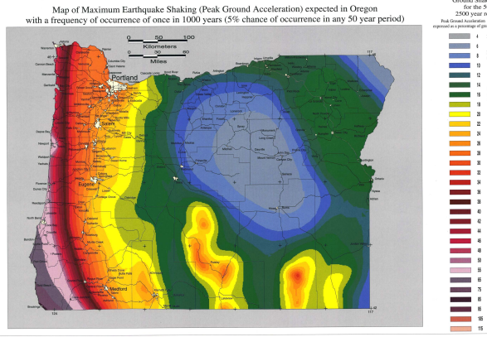
Earthquake Vulnerability
According to Washington County, Portland metropolitan area has experienced six earthquakes of 5.0 magnitude or greater, which flags Portland as earthquake-prone region, as shown in figure 2. Since Hawthorne Bridge is an old structure, it may be more susceptible to damage in the event of a major earthquake

Limited Vertical Clearance
Due to Hawthorne Bridge design as a vertical lift bridge, it has a lower vertical clearance of 14.9352 meters compared to another bridge crossing the Willamette River like the Morrison Bridge, a bascule bridge that spans the Willamette River in Portland which has a clearance of 21.0312 meters, Much higher than that of Hawthorne bridge, This low vertical clearance of Hawthorne Bridge can restrict the passage of larger vessels, impacting maritime traffic.
8figure 2
9figure 2

Age and Maintenance
Due to Hawthorne Bridge being the oldest vertical lift bridge in the United States, it requires constant maintenance and repairs to ensure its structural integrity, which can lead to traffic disruption and increased costs for the city to maintain the bridge.

Qasr-Al Nil Bridge
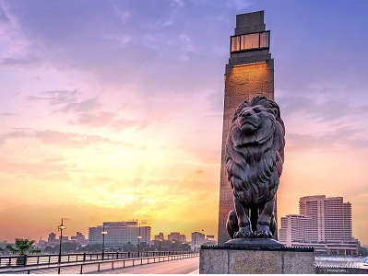
Qasr Al-Nil Bridge is a swing bridge with a movable section that allows boats to pass through the river, connecting downtown Cairo and Western Cairo, it connects Ismailia Square and the western bank of the Nile in Zamalek area similar to the European cities where a bridge links between the cities’ banks. The bridge is primarily made of steel and concrete. The idea to construct this bridge belonged to Khedive Ismail, which is why it was called “Khedive Ismail Bridge” before. It was inaugurated in 1872, and it became the artery of the heart of the Capital. It is 1,932 meters long, which makes it one of the longest bridges across the Nile in Cairo. The bridge is famous for the four bronze lion statues that sit on the ends of the bridge, as shown in Figure 1. It is interesting to note that the four bronze lion statues that were to be installed at each of the entrances to Giza Zoo were placed by Khedive Tawfiq at either end of Qasr El-Nil Bridge, to commemorate the great memory of his sire. Thus, these four lions became an essential part of the structure of the Qasr El-Nil Bridge.
10figure 1

Mechanism
Qasr Al-Nil Bridge is a swing bridge with a movable section that allows boats to pass through the river. Swing bridges operate through the rotation enabled by several gear assemblies in conjunction with a rack-and-pinion drive system. In accordance with its size, operator houses and equipment houses that house controls and machinery are mounted on either side of the bridge or on it. These include the Center Pivot, Rim Bearing, and Bobtail. Each type has its classification and advantages, making them suitable for different purposes. Qasr al-nil bridge is a center pivot type swing bridge. The design has a pivotal point in the center of the bridge and allows rotation at that point. The middle pier must be very sturdy as it will carry the weight of the whole bridge when turning. Such a bridge proves helpful at places where the waterway is wide enough for the full length of the bridge to open. The design has a balance in it, allowing ease of the operational function.

Points of Strength

Transportation Hub
Due to its central location in Cairo connecting western Cairo and downtown Cairo, Qasr al-nil bridge is considered to be a very important transportation hub in Cairo and overall essential for transportation and economy.

Historical significance
Qasr al-nil Bridge completed in 1933 has notable historical significance as it represents a symbol of Cairo’s modernization, reliance, and Egypt’s national pride. Furthermore, its strategic location gave it more historical significance as it is located near Tahir Square which made it a focal point in moments of national change.

Architectural Design
Qasr Al-Nil Bridge is admired for its architectural design and aesthetic balance as it blends modern elements with traditional values which can be seen in its modern design with the traditional lions guarding the ends of the bridge.

Points of Weakness

Maintenance Challenges
Despite the sturdy construction of Qasr Al-Nil Bridge, it requires constant maintenance to remain usable and to preserve its structural integrity, delays in this maintenance due to the bridge’s popularity and congestion would lead to deterioration of the bridge’s structure over time.

Pedestrian Overcrowding
Due to Qasr al-Nil Bridge’s popularity, the bridge can become extremely crowded with pedestrians during weekends or holidays as it is a popular location for taking pictures and is considered a tourist attraction. This makes it difficult to walk on the bridge and increases the possibility of car or pedestrian accidents.

Traffic Congestion
Qasr Al-Nil Bridge is one of the major crossings of the Nile River that suffers from severe traffic jams, especially during rush hours, which diminishes the experience for pedestrians and drivers and contributes to the noise and air pollution on the bridge.

THE TOWER BRIDGE IN LONDON:
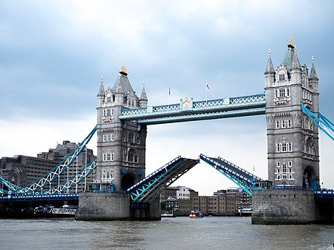
As shown in Figure (9), the Tower Bridge a grade (I) listed marvel stands tall as an iconic symbol of British engineering, spanning the river Thames near the historic Tower of London. The tower bridge was constructed between 1886 and 1894. It was designed by the architect Horace Jones and engineered by John Wolf Barry. Tower Bridge was opened officially on June 30, 1894, by Edward, Prince of Wales, and Alexndra princes of Wales. Since it was opened, the bridge has played a vital role in facilitating transportation and trade, making it a critical link between London’s infrastructure. The length of the bridge is 800 feet (240 meters) with two fantastic towers soaring to 213 feet (65 meters), the bridge boasts a central span divided into two bascules that can be raised to allow passage for waterborne traffic. During the existence of the tower bridge, has externalized the spirit of London by becoming a main part of the heritage of London and its history. It’s in Gothic style architecture that was inspired by the Victorian era.
Figure 9 The Tower Bridge in London

MECHANISM OF THE BRIDGE:
The Tower Bridge is operated with a hydraulic system. The city bridge foundation constructed it. Tower Bridge is a bascule bridge. Bascule is a French word that means seesaw. Each bascule moves around an off-center pivot, which means it looks like a seesaw in a children’s playground. Furthermore, each side of the bascule is evenly balanced, so less energy is required to open up the roads and no pressure is put on the towers. The work of opening and closing the bridge is done by eight large cogs, 1 meter in diameter four on each side, which rotate to close and open the bridge. The required power to rotate the cogs was initially supplied by steam and then in 1976 was by electricity.
Steam was the choice energy during most of the 1800s. At the tower bridge, power was generated by three large boilers fueled by stokers working in shifts, each shift is 24 hours. The steam created in these boilers was used to power the large steam pumping engines in the next room.
The engine's pistons turn large flywheels at the same time as powering a set of hydraulic pumps, which pushes water into six huge storage containers called accumulators. They act like batteries, conserving energy by keeping the water under high pressure.
When the Bridge was required to open, the water was released into the drive engines, powering more pistons to turn a set of cogs these cogs connect to a back on the rack, opening them for passing river vessels. Cogs are still used today to open Tower Bridge, but the power generated is different.
2.
In 1970, it was decided that something needed to be done to make it more efficient, reducing its emissions and making it cleaner.
A new hydraulic system launching began in 1974. Electric pumps were used to create oil-hydraulic energy to turn the cogs and open the bascules. These new engines were set up while the steam system was still in operation, so the Bridge could still open for passing river vessels. In 1976, the work was done. The Tower Bridge became electro-hydraulic powered. The old system was detached.

Points of strength:
Tower bridge efficiency:
Tower Bridge was important in London transportation because it carried 40,000 people and 21,000 vehicles. The bridge's bascules are lifted around 800-1,000 times per year to allow the passage of tall ships and river vessels.
Bascule bridge:
Its strength is that it is a bascule bridge which means that the roads move like two giant seesaws and a fulcrum to open and close the bridge. The word bascule derives from French, meaning "seesaw" or "balance".
Its long life:
Since its completion in 1894, Tower Bridge has gone through many upgrades and efforts showing its flexibility and continued service in modern times. For example, over the past years, Tower Bridge has seen many historical events, such as its important role as a transport link to the port of London during WORLD WAR II. However, the enemy attacked the bridge and it remained strong.

Points of weakness:
- Traffic:
When the tower bridge opens to pass boat traffic this increases road traffic and disrupts them. Also, it’s a Victorian design, it’s not super accessible with mobility issues.
2. Limited load capacity
When the bridge opens to pass boat traffic this increases the road traffic and disrupts it. Also, it’s a Victorian design, it’s not super accessible to those with mobility issues.
- Earthquakes bearing
Sensitivity to vibrations. When the bridge bascules (those big see-saw-like sections) open, they're subject to vibrations and oscillations. Over time, this can cause wear and tear, necessitating more frequent maintenance.

Selection Of Solution
After intensive research and analysis of the challenges and the selected location, which is Ismailia Canal, the vertical warren truss bridge design was chosen, with the swing opening mechanism to open for water traffic.

The vertical warren truss design was chosen for its properties, the first of which being efficiency due to the design simplicity as it is composed of equilateral triangles with vertical members connected to the top of each triangle, its design is relatively simple compared to other designs like the Pratt truss or the Howe truss designs and costs less materials, the addition of vertical members to the warren truss bridge was necessary as when the span length increases and the height of the truss necessarily increases, the long compression members in the top chord need bracing to minimize buckling in the vertical direction.

Secondly, the vertical warren design was chosen for its effectiveness as its design of equilateral triangles equally distributes the load among all the members of the design. The equilateral triangles connected with the joint method prevent deformation of the truss structure and keep each member under compression or tension in place.

Thirdly, for our required bridge length of 50 meters, the warren truss bridge fit all the requirements as it is relatively cheap compared to other designs like the Howe or Pratt, as its lack of effectiveness in long distances is irrelevant in this length, and its cheap price and effectiveness made it and even more appealing choice.

The center-bearing swing mechanism was chosen for the bridge due to the properties of the selected location.

Firstly, ​A swing span bridge is a bridge that rotates in a horizontal plane around a vertical axis into a position parallel with the marine channel and shore, allowing boats and ships to pass along a waterway that would otherwise be obstructed by the bridge. Due to the narrow water width of our location along the Ismailia canal of 50 meters, the swing span mechanism was chosen as it is designed to use less water space when open.

Secondly, the center bearing design was chosen as it is lighter and easily operated and maintained as the mechanism is inherently low friction and thus doesn’t require high levels of maintenance or lubrication and its high efficiency as the power required to move than span is less than other movable bridge types and provides an even distribution of loads onto the center bearing.

Selection of prototype:
The materials recommended for use in our prototype should be recyclable and sustainable, like palm trees. While choosing the material for the prototype the term ‘Tensile strength’ should be considered. The tensile strength is the strength of the material and how it performs. Palm trees will be a main component in the prototype. Palm trees will be used in the manufacturing of trusses and unmovable parts. Palm is a strong material to make the truss. We could divide the strength of the palm tree according to the parts in it. The tensile strength of the palm fiber (Mpa) is 68, and Young’s modulus (Gpa) is 3.774. Palm trees are suitable as they have a distinct structural design that contributes to their strength and can be found anywhere. The truss is made from mild steel that has an ultimate tensile strength of 400-550 Mpa and yield strength of 250 Mpa. Steel has things in common with palms as they are both known for their strength in tropical storms. When the palm truss succeeds in the prototype, the real truss will succeed. Sticks will be used on the deck and the cords. Thick pillars of the palm tree would be like beams. Pully and threads are used between the beam and the bear to open and close the bridge. Pully and threads are available everywhere and are suitable as they are the best way to open and close it.

The truss that will be used in the bridge is the Warren truss which can distribute the load equally on the bridge due to the arrangement of the triangles, warren truss can hold an average weight of 35.16 kilograms, and the high and low outliers with a maximum weight of 50.85 kg and a minimum weight of 15.5 kg. The Warren truss is efficient for short bridges, its cost isn’t too much, it is easy to construct and it's a very stable structure. The number of 50-meter warren truss is 21 members and 10 diagonals and the same as the prototype it only differs in physical size. The number of unique angles in the end triangles is 6 angles while in the middle triangles are 8, so the total unique angles in the truss are 14. The mechanism of opening and closing the bridge is the center pivot swing bridge. The swing bridge is a bridge that can be rotated horizontally around a vertical axis. Swing bridges are also suitable for great spans and do not limit the clearance. This pivot is supported by a powerful central pier, designed to bear the weight of the bridge as it swings open and closed. The center pivot design offers a central point at the midpoint of the bridge, allowing it to rotate around the central axis. This type of bridge is effective when the waterway is wide enough to accommodate the full length of the bridge when it swings open. The balanced design confirms smooth and efficient operation, making it a popular choice for road and rail applications.

The dimensions of the prototype are as follows: the scale is 1:50. The total length of the bridge is between 80 and 100 cm. The bridge has two lanes of traffic, and the width of the traffic lane is 7 cm. It also has two lanes for pedestrians with a width of 3cm. An island of 2cm exists in the middle width of the bridge. The clearance between the water level and the lowest point of the deck of the bridge is 10 cm. The bridge should allow the passage of ships that need a minimum width of 24cm a maximum width of 28cm and a minimum height of 20cm. The bridge should be able to carry a traffic load of a minimum 10 kg mass at the midpoint of the bridge of the largest fixed span. The maximum deflection at the same point doesn’t exceed 5 cm without collapse. The maximum weight of the prototype shouldn’t be more than 20 kg. By these dimensions, the bridge will meet the design requirements. When the dimensions of the prototype succeed the solution will succeed as These dimensions are well calculated and they will make the prototype efficient. By this, the bridge will allow safe passage of the ships and carry the traffic across water areas.

Design requirements:
To make a successful bridge, you must follow these design requirements:
The constructed prototype scale is 1: 50. The length of the bridge should be between 40 and 50 meters. The weight of the prototype shouldn’t be more than 20 kg. The distance between the lowest point of the deck and the sea level should be 5 meters or more. The bridge must have two lanes of traffic vehicles (The width of the traffic lane is 3.5 meters) and two lanes for pedestrians (The width of the pedestrian lane is 1.5 m). An island of 1 m should be provided in the middle width of the bridge. The bridge should allow ships to pass. The ships require a minimum width of 12m and a minimum of 10 meters height over the water surface (table or ground for the prototype) through the movable part of the bridge. The mechanism of opening and closing the movable part of the bridge could be either mechanical or hydraulic.The bridge must carry a simulated "traffic load" of a minimum 10 kg mass (not scaled) placed on the structure at the mid-point of the largest fixed span. The maximum deflection, at the same point, does not exceed 5 cm (not scaled) without collapse. Measure and present a graph of the relationship between the load (increasing from zero to the maximum) and the corresponding deflection at the same point.
Requirements Solution
Ability of the Material
The material chosen for the suspension bridge prototype demonstrates exceptional adaptability, particularly for structures requiring both flexibility and support. Its natural composition makes it a versatile resource, easily shaped and crafted to meet precise design specifications. This flexibility allows it to withstand variations in tension and compression, adjusting to shifts in weight and load distribution without compromising structural integrity. Additionally, the material’s lightweight nature reduces the strain on the bridge’s foundation, enhancing stability. This adaptability is invaluable in prototype development, as it simplifies the construction process and reduces the need for complex adjustments during assembly.

Strength of the Material
Remarkably strong and resilient, the chosen material can endure considerable loads and resist wear over time. It is characterized by a sturdy core, which provides the bridge with a reliable base capable of supporting pedestrian or light vehicular traffic as intended in prototype testing. Despite its moderate weight, this material boasts impressive tensile strength, ideal for withstanding dynamic forces on a suspension bridge. Its fibrous structure enhances durability, allowing it to absorb shocks from movements and environmental forces, such as wind or minor seismic activity. This robust quality ensures the bridge remains safe and effective throughout its lifespan.

Sustainability of the Material
Sustainability is one of the standout advantages of this material, as it originates from a renewable, widely available source that minimizes environmental impact. Unlike conventional construction materials, its use promotes eco-friendliness and helps reduce dependency on finite resources. The material’s biodegradable nature also means it leaves a minimal footprint, aligning well with environmentally conscious building practices. Additionally, utilizing locally sourced materials cuts down on transportation emissions and supports regional economies. This sustainable characteristic not only benefits the environment but also aligns with modern engineering goals, making it an ideal choice for eco-friendly infrastructure projects.

